9. Creating views to provide a customized view of the database.

Create a Table
create table employees7(
emp_id int primary key auto_increment,
emp_name varchar(50),
department varchar(30),
salary decimal(10.2)
);
select*from employees7;

Insert some sample data
insert into employees7(emp_name,department,salary)values
('shivani','it',20000),
('rita','it',40000),
('radha','hr',52000),
('samu','finance',50000),
('priya','finance',30000),
('diya','hr',38000);
select*from employees7;

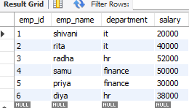

1. Simple View
create view employees7_salary_view as
select emp_name,salary
from employees7;
select*from employees7_salary_view;
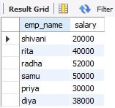

2. Filtered View
create view it_employees7 as
select emp_id,emp_name,salary
from employees7
where department='it';
select*from it_employees7;

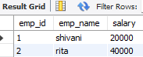

3. Aggregated View
create view department_salary_summary as
select department,
count(*)as total_employees,
sum(salary)as total_salary,
avg(salary)as avg_salary,
max(salary)as highest_salary,
min(salary)as lowest_salary
from employees7
group by department;
select*from department_salary_summary;

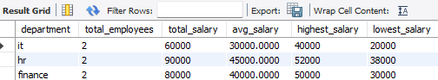

4. Updating a View
create or replace view employees7_salary_view as
select emp_name,department,salary
from employees7;
select*from employees7_salary_view;

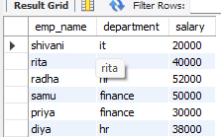

5. Dropping a View
drop view if exists it_employees7;

